Practical: - 5

Aim: - 1. Calculate and display the total number of students enrolled in the following subjects.

Mathematics, Science, Physics.

SQL> create table student_info (studentid int, name varchar (10), subject varchar (20));

SQL> desc student_info;

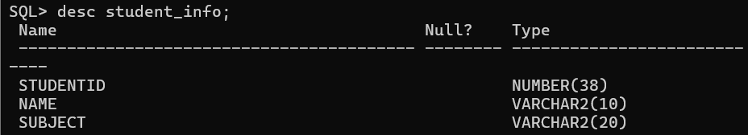

SQL> INSERT INTO STUDENT_INFO (STUDENTID, NAME, SUBJECT) VALUES (1, 'ANJALI', 'MATHS');

SQL> INSERT INTO STUDENT_INFO (STUDENTID, NAME, SUBJECT) VALUES (2, 'RAVI', 'SCI');

SQL> INSERT INTO STUDENT_INFO (STUDENTID, NAME, SUBJECT) VALUES (4, 'RUPA', 'EWS');

SQL> INSERT INTO STUDENT_INFO (STUDENTID, NAME, SUBJECT) VALUES (4, 'RUPA', 'EWS');

SQL> SELECT * FROM STUDENT_INFO;

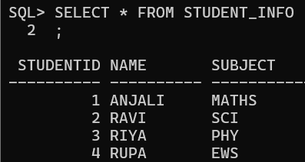

SQL> SELECT COUNT(SUBJECT) FROM STUDENT_INFO WHERE SUBJECT='MATHS';

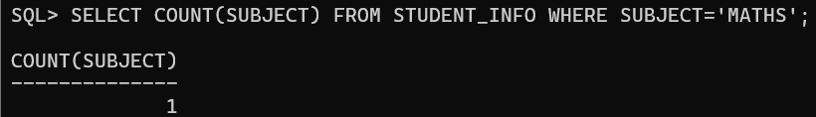

SQL> SELECT SUBJECT, COUNT(SUBJECT) FROM STUDENT_INFO GROUP BY SUBJECT

ORDER BY SUBJECT;

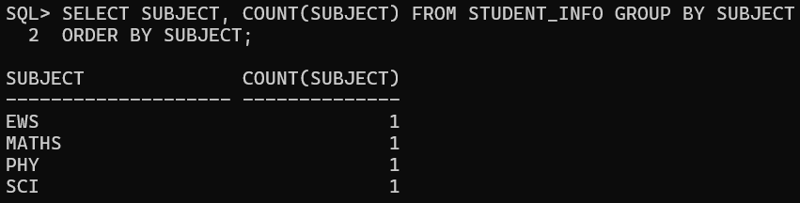

SQL> ALTER TABLE STUDENT_INFO ADD MARKS INT;

SQL> DESC STUDENT_INFO;

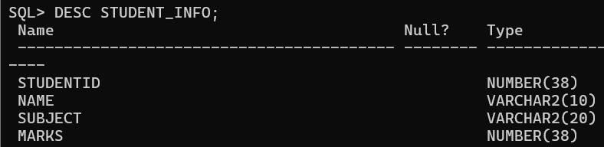

SQL> INSERT INTO STUDENT_INFO (STUDENTID, NAME, SUBJECT, MARKS) VALUES (1, 'ANJALI', 'MATHS', 25);

SQL> INSERT INTO STUDENT_INFO (STUDENTID, NAME, SUBJECT, MARKS) VALUES (2, 'RAVI', 'SCI',23);

SQL> INSERT INTO STUDENT_INFO (STUDENTID, NAME, SUBJECT, MARKS) VALUES (3, 'RIYA', 'PHY',20);

SQL> INSERT INTO STUDENT_INFO (STUDENTID, NAME, SUBJECT, MARKS) VALUES (4, 'RUPA', 'EWS',22);

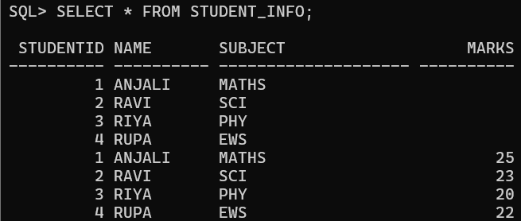

SQL> SELECT SUM(MARKS) FROM STUDENT_INFO WHERE SUBJECT='MATHS';

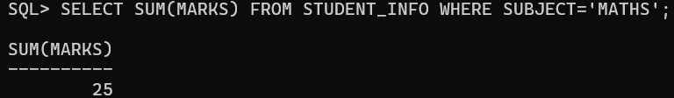

SQL> SELECT * FROM STUDENT_INFO WHERE NAME LIKE 'A%';

